CTM-I Use Case

Status Display

Version 0.1

Use Case Name | Status Display
Actor | Market Ops, Operations, App Support
Pre-conditions /Assumptions | User has Browser and is aware of the http path to the application.  User has successfully logged into the CTM-I application.  User has the right role to see the menu options.
Post Conditions | None
Screenshot | 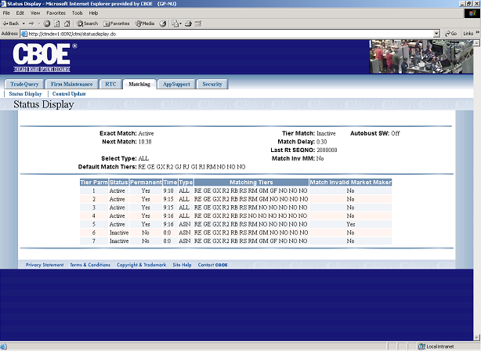
Flow of Events | - User selects “Status Display” from the menu.  - Requests are sent to CTM-R to get all the data required.  - Status Display screen displays.  - All the fields are read-only, nothing can be changed on the screen.
Alternative Path | None.

